HomeGenie for Dummies

An Intro

Introduction
This document is written with the intent to fill some gaps in the currently available HomeGenie documentation. Its goal is especially to help the new user.

General X-10 Hardware Setup
While HomeGenie supports numerous home automation hardware vendors, this document is written by an author who uses primarily X-10. We wont go into the details of the X-10 infrastructure much except to spell out a particular installation that has proven reliable in an example home. X-10 reliability is a well known and very frustrating issue but it can be conquered if you know the secrets (below).

An example (99.5% reliable) X-10 HomeGenie setup may include these components:

X-10 automation hardware of choice (modules, switches, sensors, etc)
XTB-IIR X10 Booster and Repeater from JV Digital Engineering
WGL V572 RF Transceiver from WGL Designs

HomeGenie Hardware Setup / Notes
HomeGenie runs on multiple platforms. Our example setup has it running on a cheap netbook loaded with Ubuntu Linux. You will see many people talking about running it on Raspberry Pi hardware. Pogoplug would also be a nice platform for HomeGenie but I haven’t seen anyone who has installed it on one yet. Headless hardware (no monitor or keyboard) is perfectly suitable for HomeGenie since it runs generally as a service (background program) and can be accessed fully from another computer through a web browser. Once installed on a machine, you can access the GUI by pointing your web browser to the IP Address of that machine and optionally port 80 (ex: 192.168.1.31:80).

Our example home automation setup as mentioned above uses X10. In order to couple control signals from HomeGenie onto the power line, one needs some sort of power line modem. The most common device for this (again, with X10) is the CM15A Active Home Pro controller. This controller has the ability to run its own automation macro’s etc but in this case, we use it only as a modem. The capabilities and reliability of HomeGenie far outweigh those of Active Home Pro. To use the CM15A as a power line modem only, just clear the interface memory and don’t load anything into it. Connect a USB cable from your HomeGenie controller to the port on the CM15A. Then plug the CM15A (ideally) into the boost port on the XTB-IIR. The CM15A USB interface is bi-directional and will both send and receive commands to/from HomeGenie.

A first example
So lets go through a typical introductory example. The goal here is to add an X10 appliance module and schedule it to come on at dusk and go off at dawn. This is a pretty common request. Here we cover the steps and point out some pitfalls so it goes smoother for you.

Add the module
Start by going to Configure | Groups
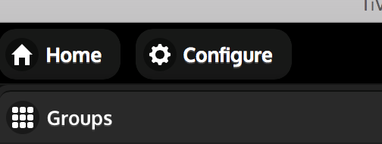

You’ll see “Dashboard” listed. Don’t worry about that right now, you can come back to it later after you add some modules to your configuration. Once you do that, you can use the Dashboard tab to configure what HomeGenie will show you as its “home page”.

If you haven’t created a group yet, now would be a good time to make one. We’ll create a group called Northridge and this group will contain all the modules in our home.

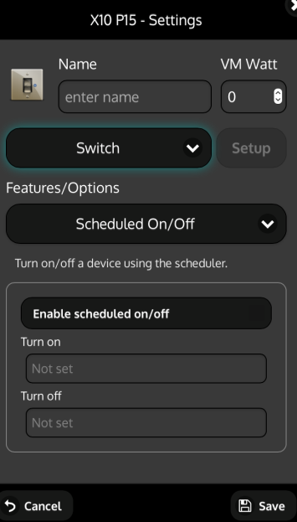
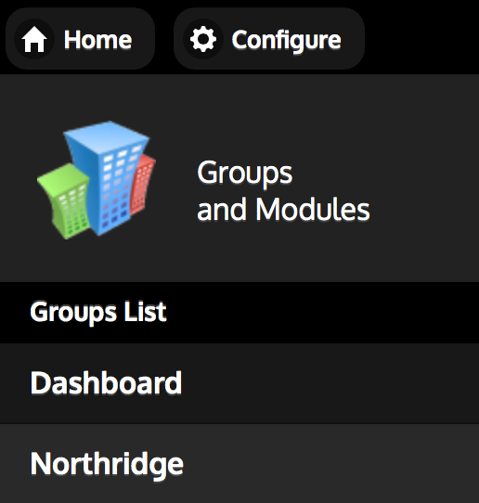

Go into your group and from the lower right corner, click Actions | Add Module. From here you can pick a particular X10 Address and the module will be added. Next you want to configure the module by clicking the little gear:

You should see something like this come up:

Here you should enter a memorable name to this module and select the type of module you are using (switch or dimmer or light most commonly).

Now, we want to configure this light to come on at dusk and go off at dawn. There are some pitfalls here so pay attention.

You MUST click the nearly invisible button next to “Enable Scheduled On/Off”
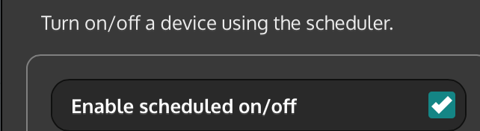

Now it is time to enter the turn on and turn off times. Don’t be fooled into typing in something like 9:00pm or anything like that. While you can type that sort of thing in, it won’t work. You have to use either special @ commands or direct cron syntax. Cron syntax is documented numerous places throughout the internet but keep reading, there is a special helper available for coming up with these strings.
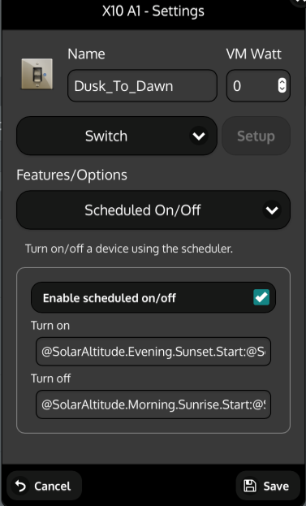
Here is an example of what I have for my dusk/dawn modules.

Because X10 is a little dicey I’ve added TWO times for Sunrise and Sunset that are a few minutes apart from each other. Note the Colon (:) , this is important, it tells HomeGenie to do things at BOTH time points.

@SolarAltitude.Evening.Sunset.Start:@SolarAltitude.Evening.Sunset.End
@SolarAltitude.Morning.Sunrise.Start:@SolarAltitude.Morning.Sunrise.End

For these particular @ commands to work you must have enabled Solar Altitude in Configure|Programs|Environment and you’ll need to property enter your lat/long. As an example, the latitude and longitude for Longmont Colorado needs to be entered as such:
40.040369
-105.057659
This example is provided because it has proven difficult to find documentation on this.

Here is an example of what was entered for a light that comes on at dusk and goes off at 10:30pm
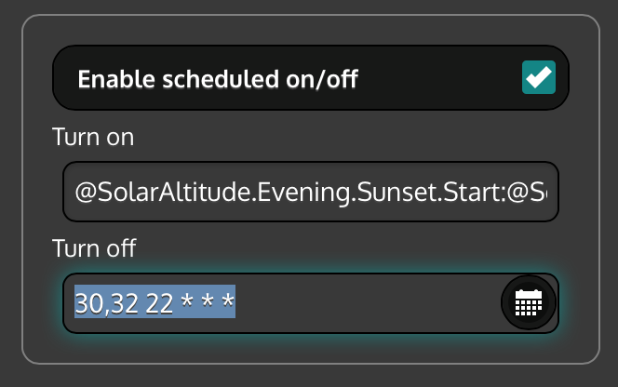

You can click the little calendar icon for help constructing the cron string.

This should get you going with Dusk/Dawn scheduling. Just repeat this sort of thing for every module you want to come on at dusk and off at dawn etc.

One caution, you may see a Scheduler widget within HomeGenie. My advice is to steer clear of that thing. I couldn’t figure out what it does and wasted a lot of time with it. If you want to schedule module activity, just do the above for each module.

Other Random Thoughts
- You’ll see other things in the module dialog besides “Scheduled on/off”. These items apparently can also be activated for the module and configured appropriately. I have not messed with any of those and in fact, have disabled most of them by going to the Config | Programs section.

- There seems to be no way for HomeGenie to tell you what it is going to do in the future, only what it has done in the past. The best way to get this history data is through the mono logfile which needs to be set up manually. To get the mono log saved, edit /usr/local/bin/homegenie/startup.sh and redirect the output of HomeGenie to some sort of logfile. The following figure shows a modified file:

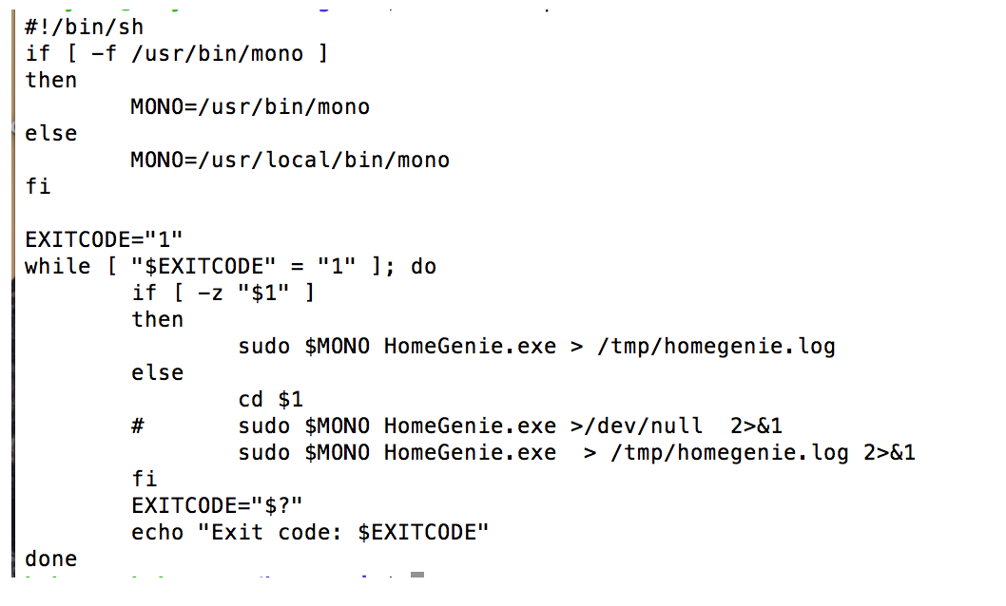
http://www.homegenie.it/forum/index.php?topic=1367.msg8763#msg8763

- Look at /usr/local/bin/HomeGenie in Linux for the binaries

- It is pretty cool that you can turn on or off a particular module just by pointing your browser to your HomeGenie server and using a URL like this:
http://192.168.1.34/api/HomeAutomation.X10/A6/Control.On
This can work from anywhere in the world as long as your port forwarding is set up correctly and any dynamic DNS stuff is properly updated (I recommend duckdns.org for this).

Conclusions
I hope this short guide will be of use to someone. Feel free to modify and augment this doc as you see fit.

